
________________________________________________________________________________________________________________________________________________________________________________________________________
Welcome to the official ASR webpage! The Axos Socialist Republic is a Minecraft empire based on the server REDACTED. Founded on June 15th 2025 by Lordos Axos, or AxoFX. The capital of the ASR is Axford, one of the largest cities on the server. Well known for being far more advanced than its counterparts in organization, innovation, and leadership.


Ranking
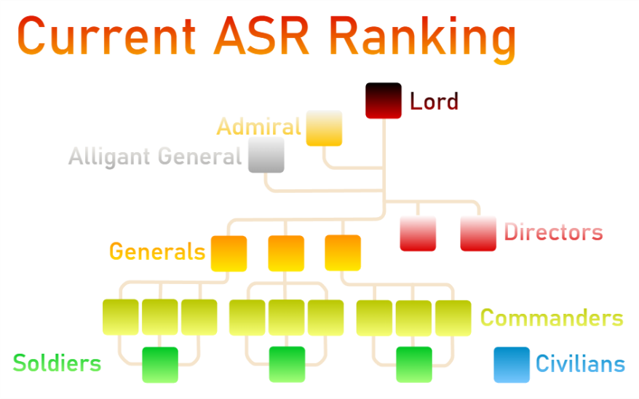
The ASR has a complex ranking system based around legions further broken down into divisions. At the very top are the Lord, Admiral, and Alligant General; Together they lead the ASR to a brighter, socialist, future. Below them are the Militant Director and the Civil Director, who use scientific research to bring benefit to the public and the military. Then there are the Generals, there are 3 and each one leads a legion. The Generals lead the Commanders; there are three of them in each legion. Each commander leads a division, the three divisions in legion are: Ground Force, Air Force, and Sea Force. Within the divisions are Soldiers, they have some combat training and environment training (based off their division speciality). And finally, below commanders and equal to the Soldiers are Civilians, simple unranked people who are the most vital part of the ASR.

Prefecture

The ASR consists of Prefectures, smaller areas or districts of the greater empire. The main Prefecture is Axfordshire, obviously, surrounding Axford. Generally, each Prefecture has its own sub-capital. However, they are all administered directly from Axford. Connecting the Prefectures are 4 classes of roads, canals, railways and telegraphs. The class of a road is indicated by a coloured stripe down the middle of it, A red stripe means small, 2 lanes. Orange is large, 4 lanes. Yellow is speedway, 2 ice tracks. And finally, the 4th is an unclassed road, usually 2 lanes and without a coloured stripe. Unclassed roads are very rare and are usually used in non-public military bases or just test roads.

Media
The ASR has many forms of media, such as documents, spreadsheets, images, and videos. Most of these have copyright on them so please do not violate it. This Webpage in fact has copyright protection, noted at the bottom of the page. With other forms of media videos may have a copyright disclaimer at the beginning, spreadsheets may have it noted at the top, and images will have the copyright noted as a description or at the back of the document its in. Some media is also classified such as research documents we do not want enemies to see; these will have copyright on them and a note at the top saying “CLASSIFIED” and just below that the minimum rank requirement to read it. Reading, owning, giving, or buying these documents is a violation of ASR Law.

Consult
You can consult us via these email addresses:
Main ASR: AxosUnion@outlook.com
Lord: AxoWasTaken@outlook.com
Admiral: Currently Unavailable
Alligant General: Currently Unavailable
Content on this site is licensed under CC BY-NC-SA 3.0 unless otherwise noted. Not an official Minecraft website; Nor are we associated with Mojang or Microsoft.

